1. ePuma_NAV_EAviation_DEV_incr

variables:

task : Dev21

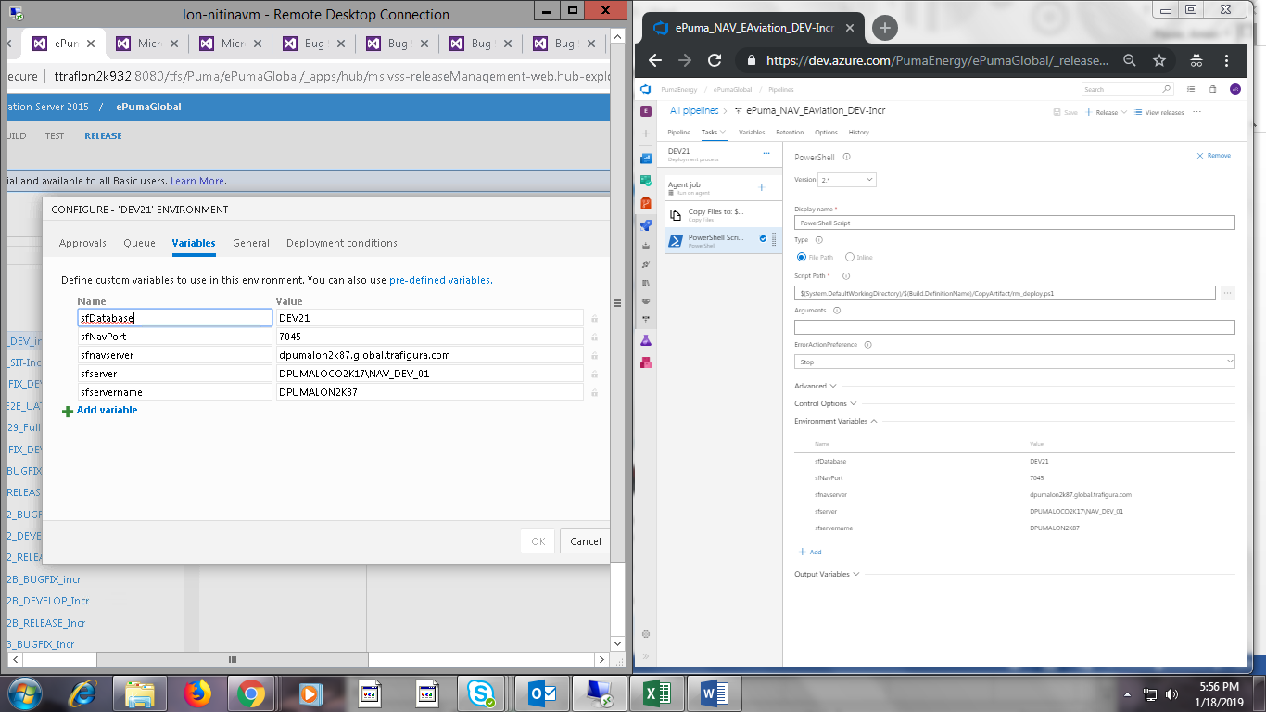

1. ePuma_NAV_EAviation_SIT-Incr

Variables:

Task : Test 21

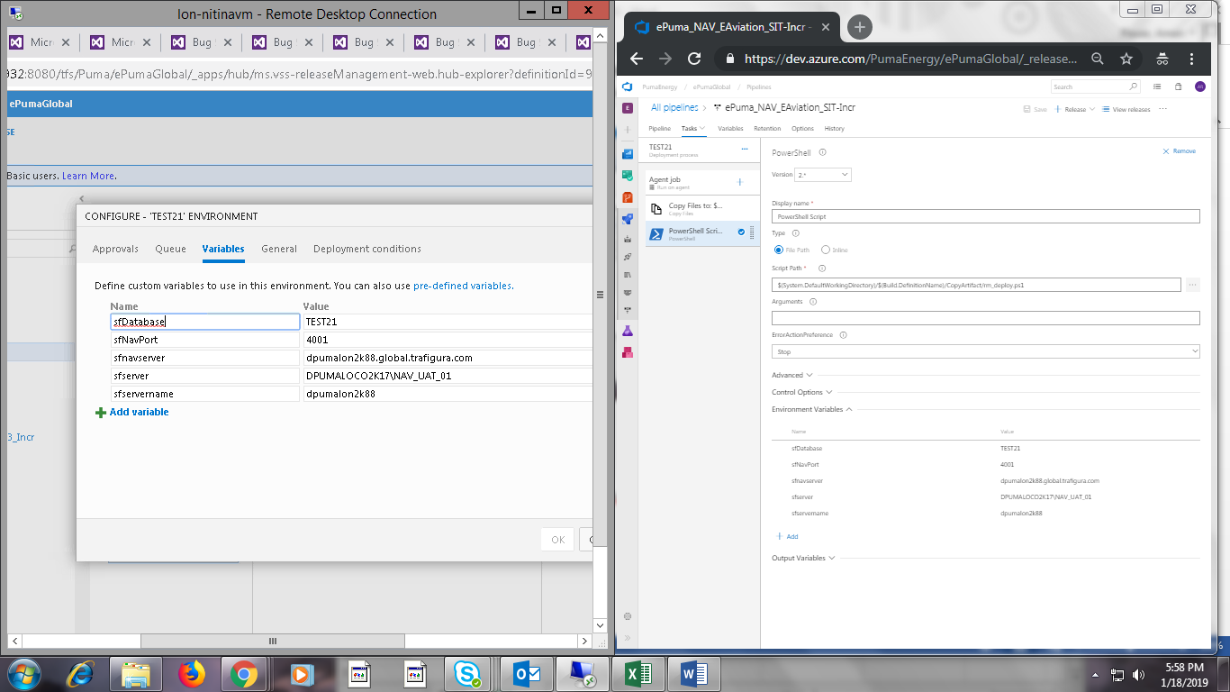

Task : Test30:

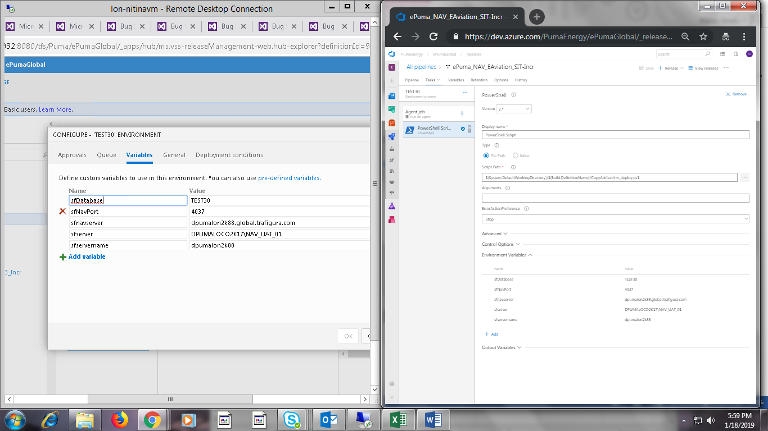

Task: Dev40

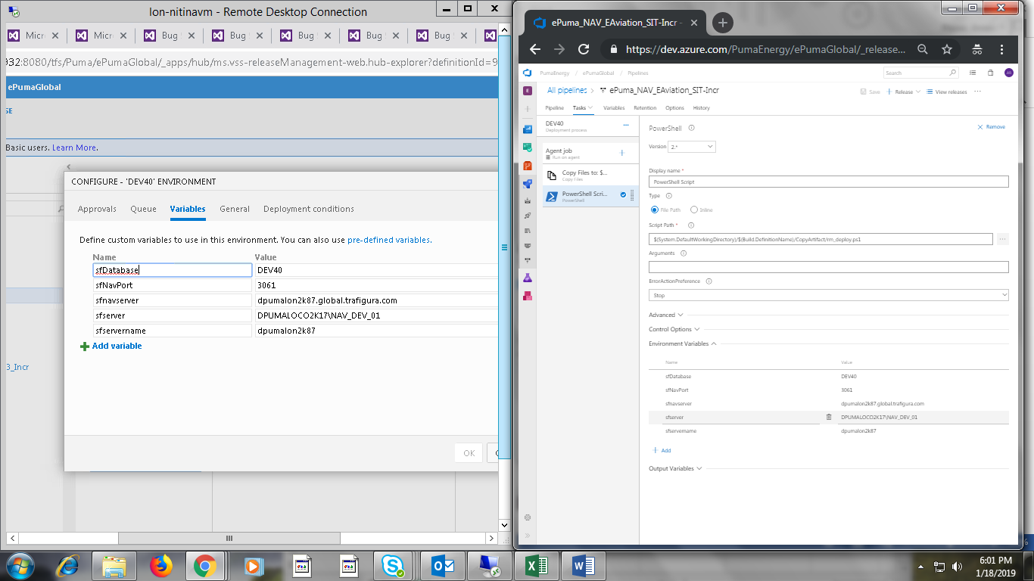

3. ePuma_NAV_WP1_BUGFIX_DEV29_Incr

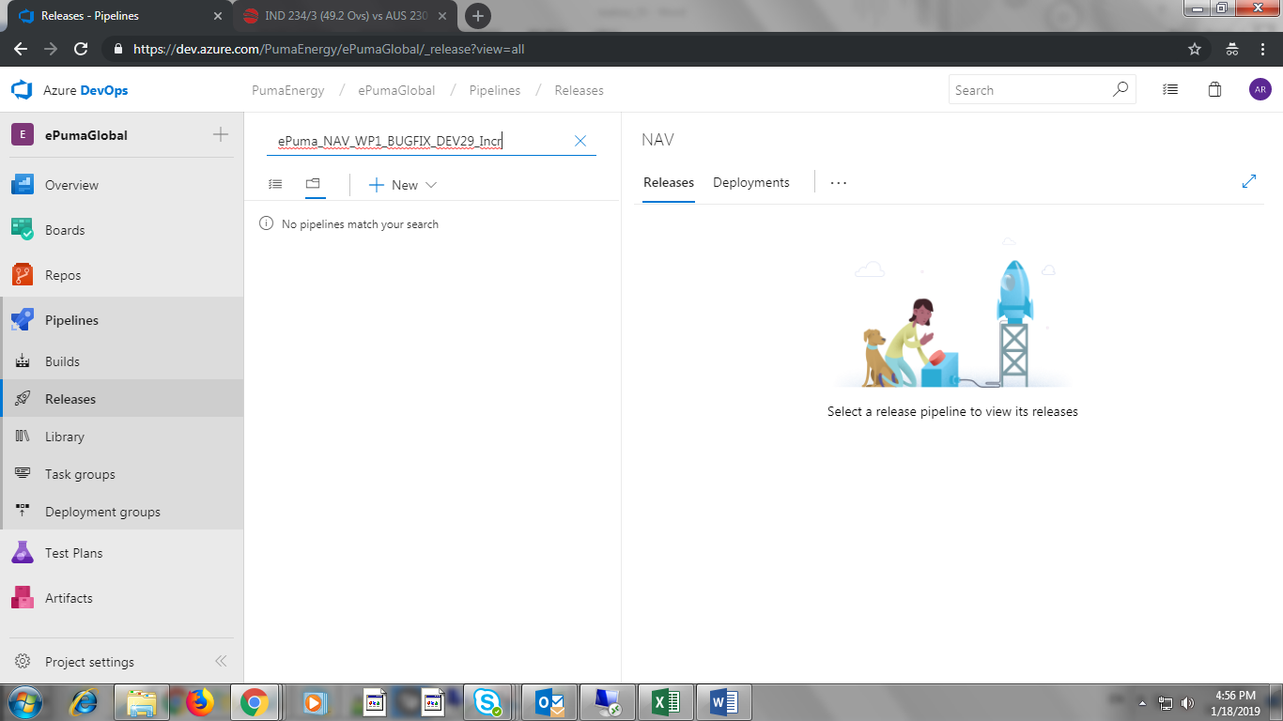

4. ePuma_NAV_WP1_SIT_E2E_UAT_Incr

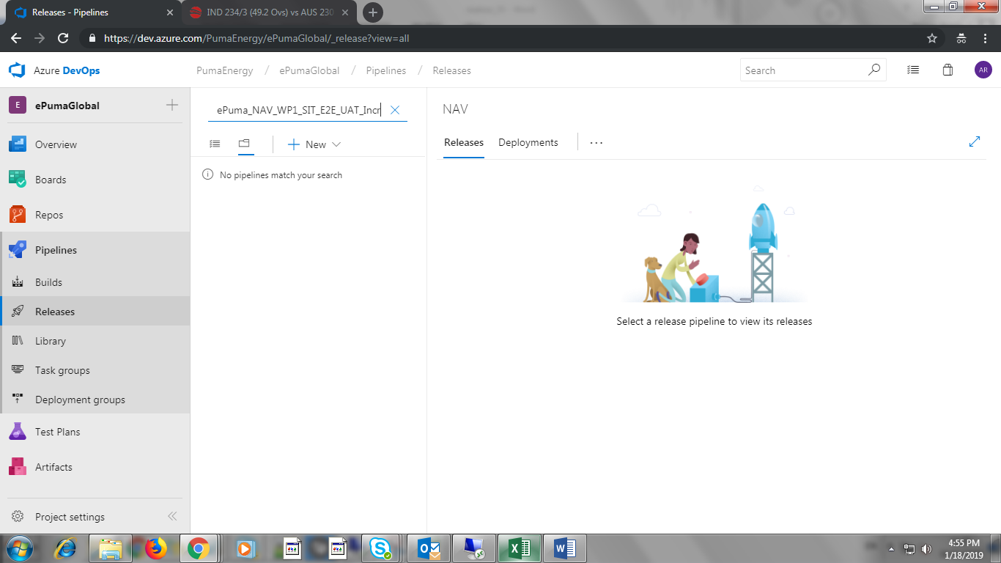

5. ePuma_NAV_WP1_TEST29_Full

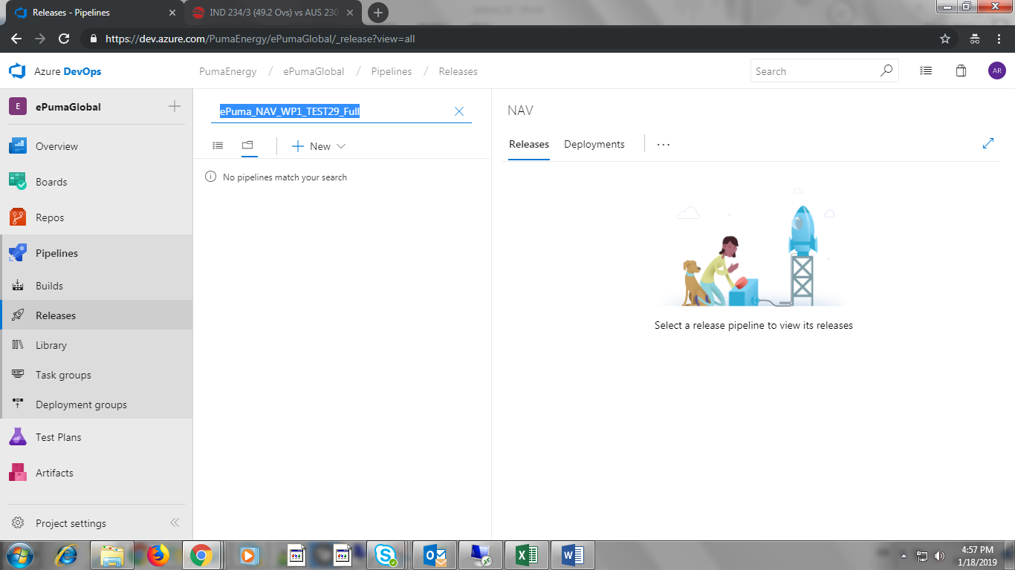

6. ePuma_NAV_WP3_BUGFIX_DEV23_AzureDEV23_Incr

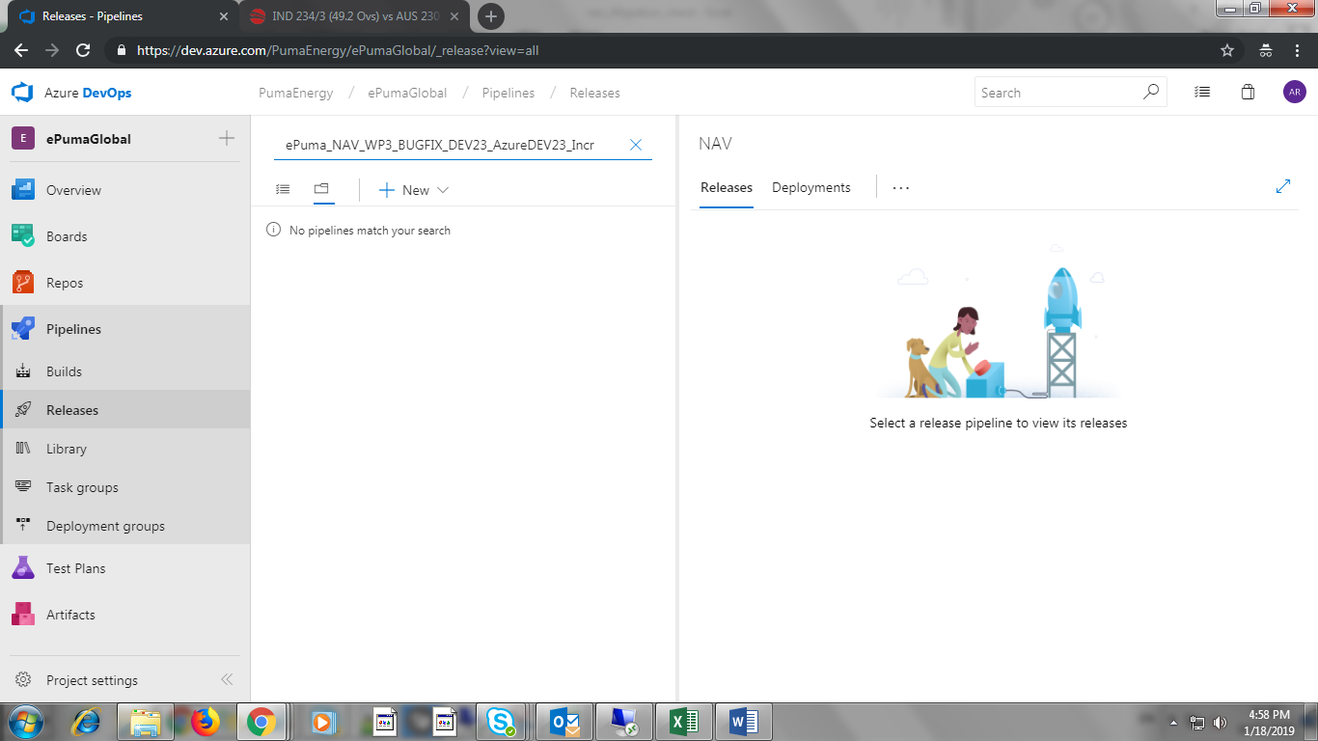

7. ePuma_NAV_WP3_OC_BUGFIX_inr

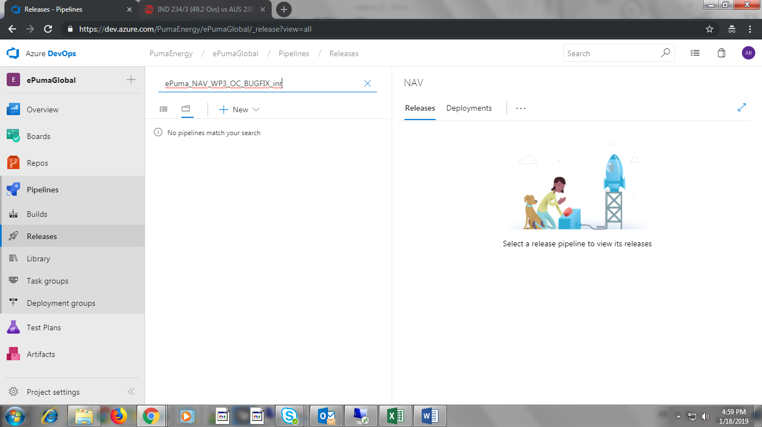

8. ePuma_NAV_WP3_OC_RELEASE_Incr

Task: UAT22

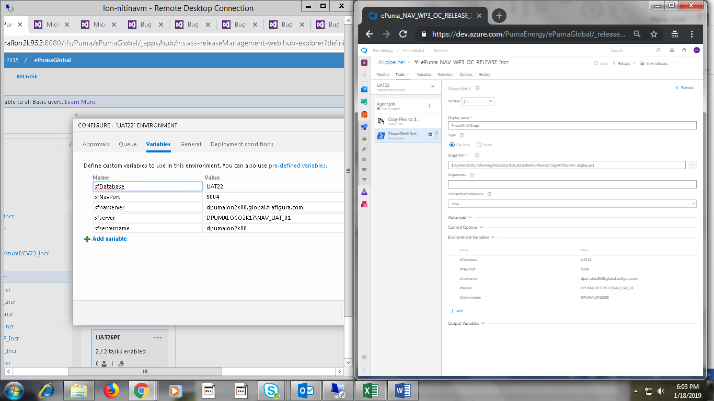

Task : UAT26

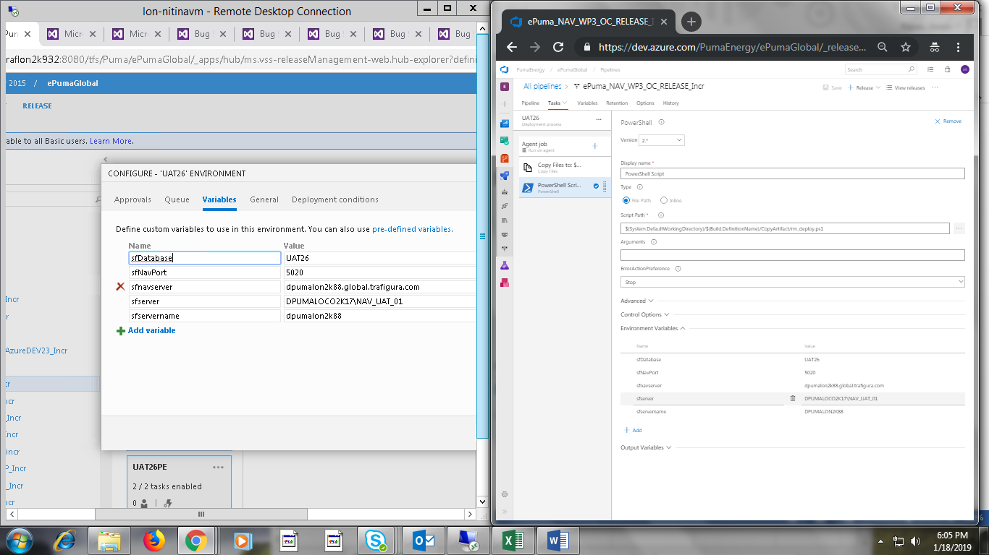

9. ePuma_NAV_WP3_R1D2_BUGFIX_Incr

Task: Dev24

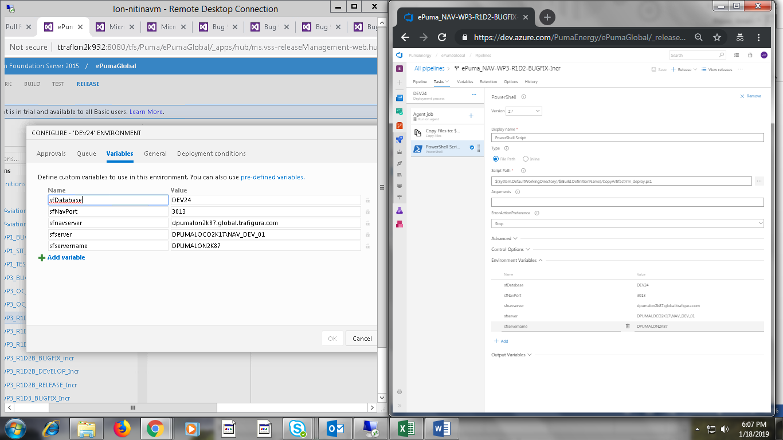

10. ePuma_NAV_WP3_R1D2_DEVELOP_Incr

Task: Dev30

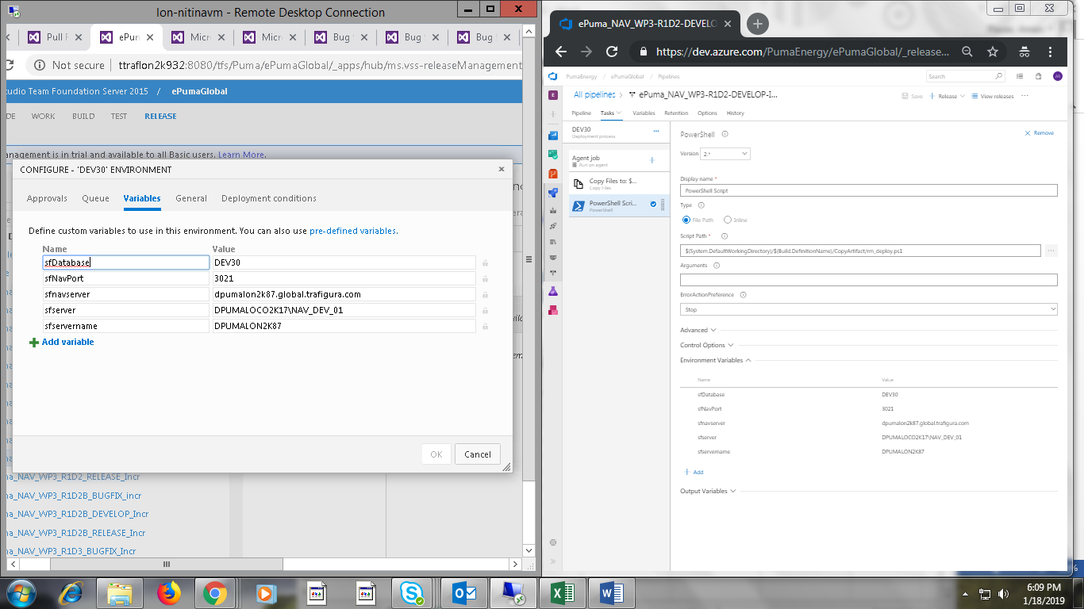

11. ePuma_NAV_WP3_R1D2_RELEASE_Incr

Task: Test24

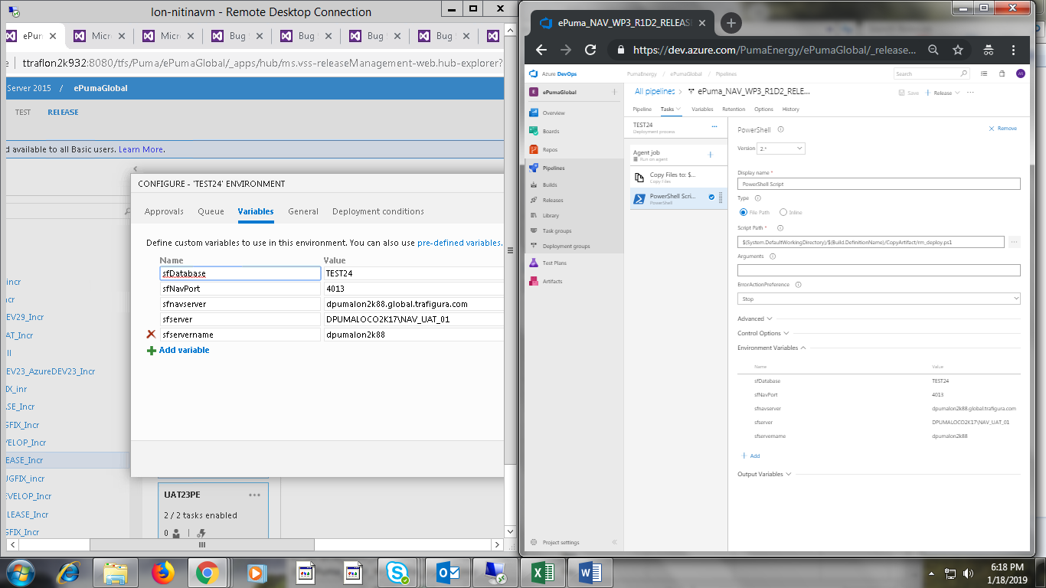

Task: UAT23

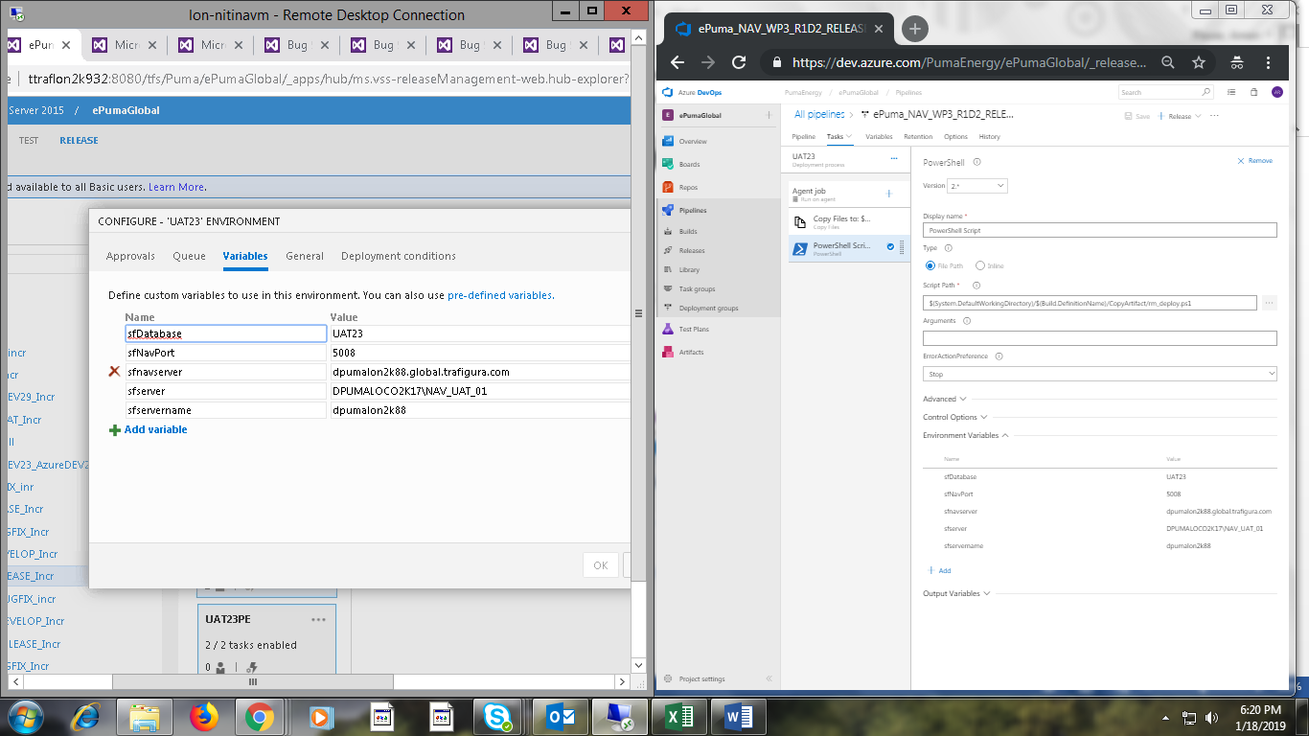

12. ePuma_NAV_WP3_R1D2B_BUGFIX_incr

Task: Test23

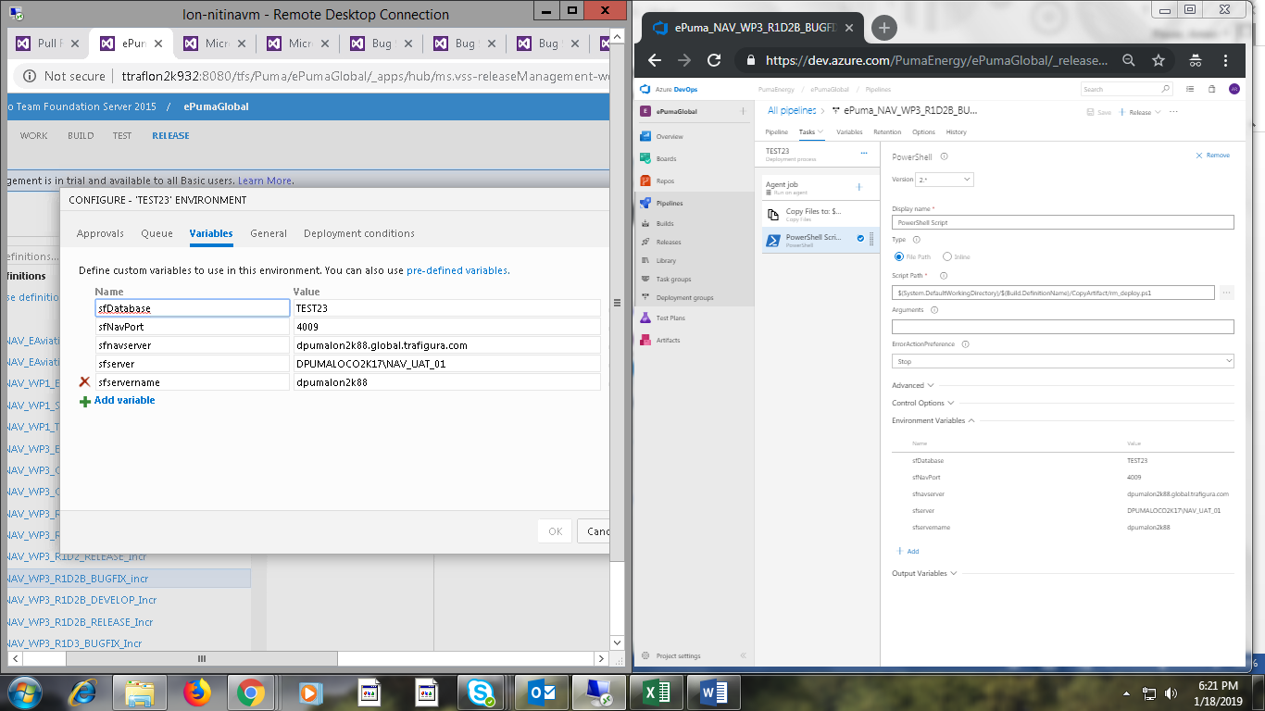

13. ePuma_NAV_WP3_R1D2B_DEVELOP_Incr

Task: Dev34

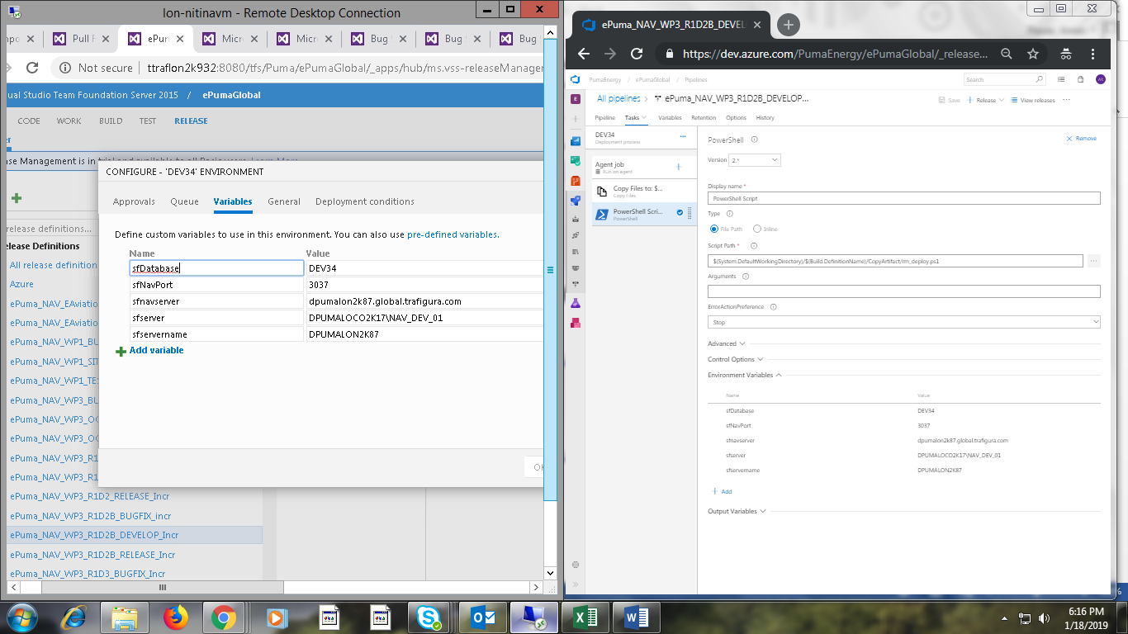

14. ePuma_NAV_WP3_R1D2B_RELEASE_Incr

Task: E2E23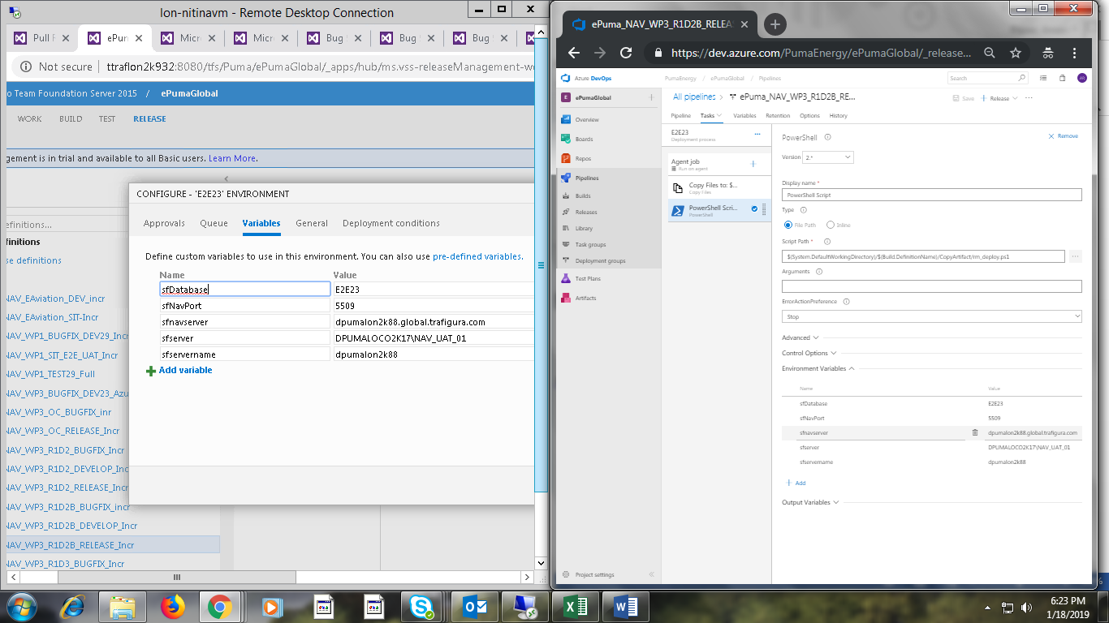

15. ePuma_NAV_WP3_R1D3_BUGFIX_Incr

Task: Dev32

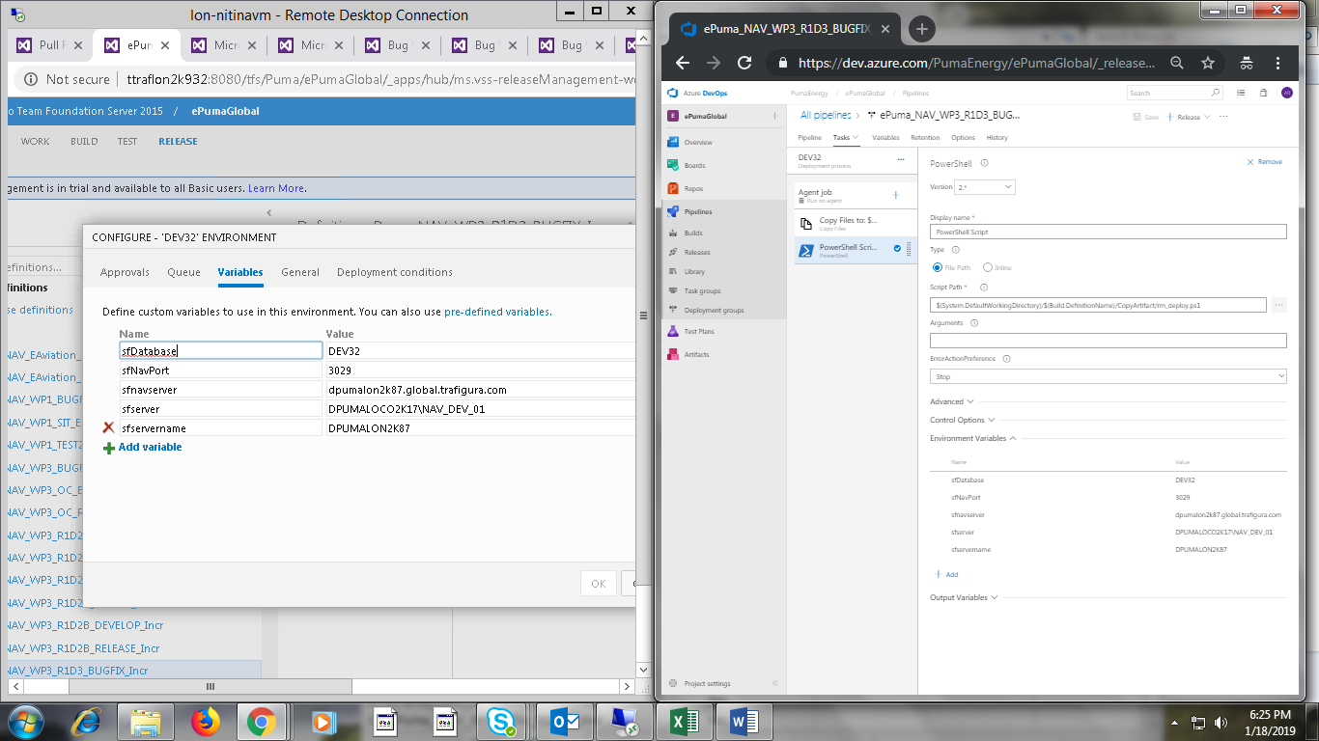

16. ePuma_NAV_WP3_R1D3_DEVELOP_incr

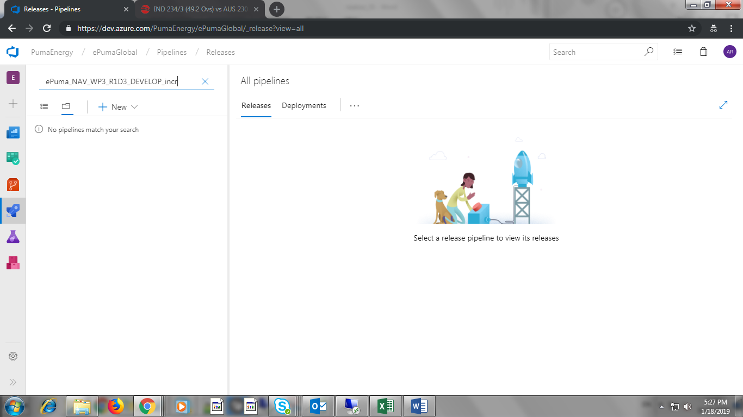

17. ePuma_NAV_WP3_R1D3_RELEASE_Incr

Task: Test22

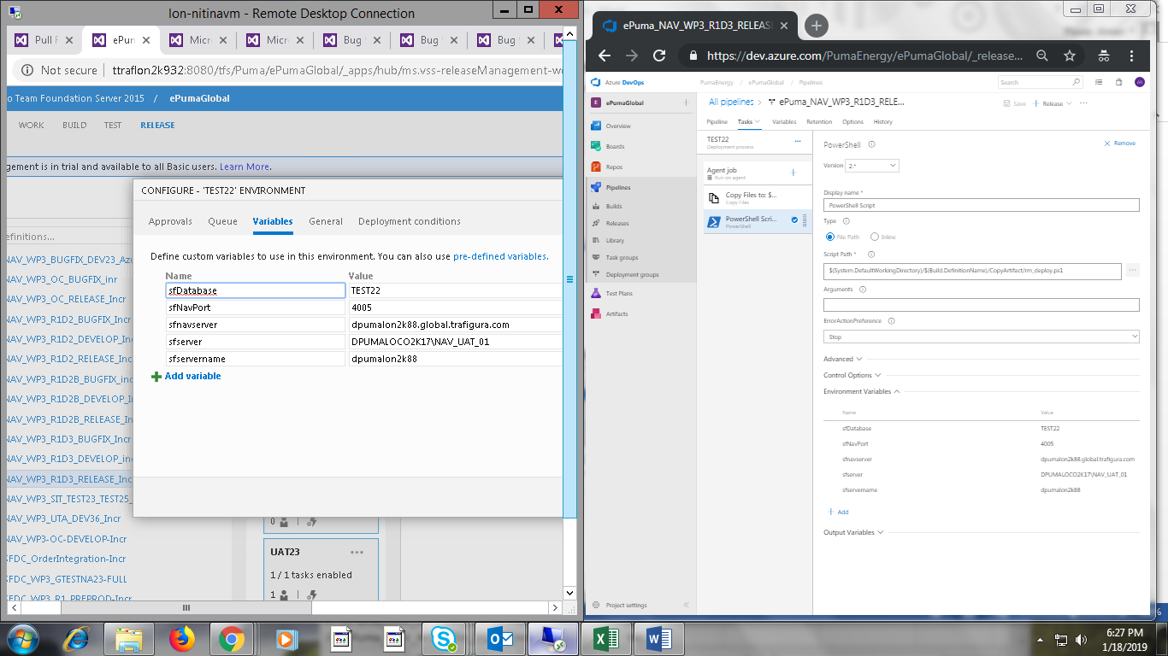

Task: Test27

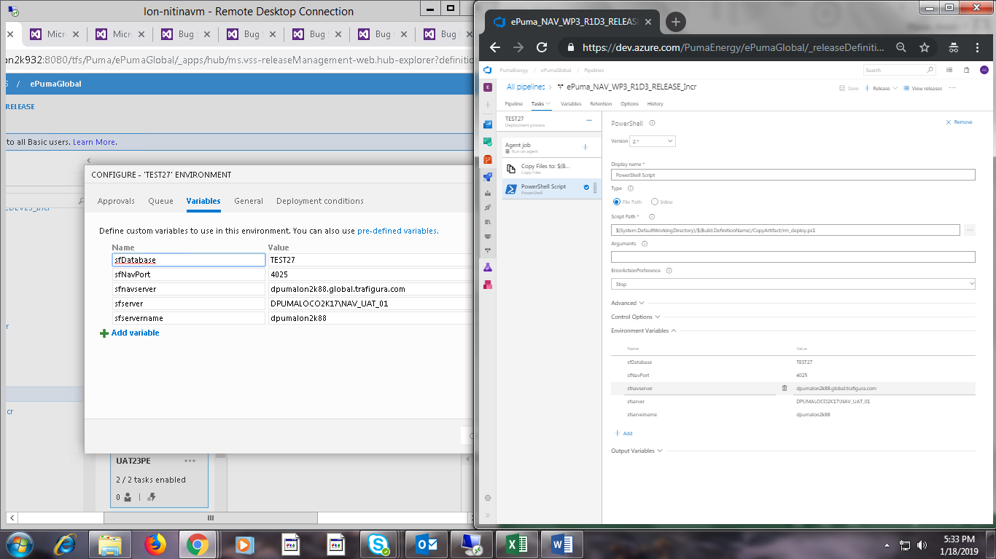

Task: PT21

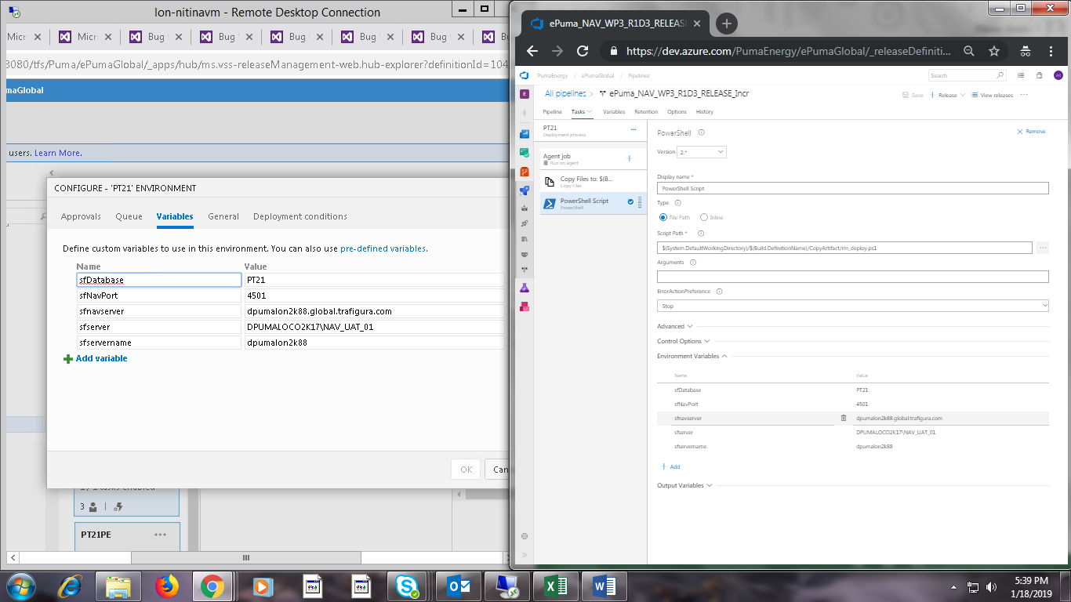

Task: UAT23 and UAT27

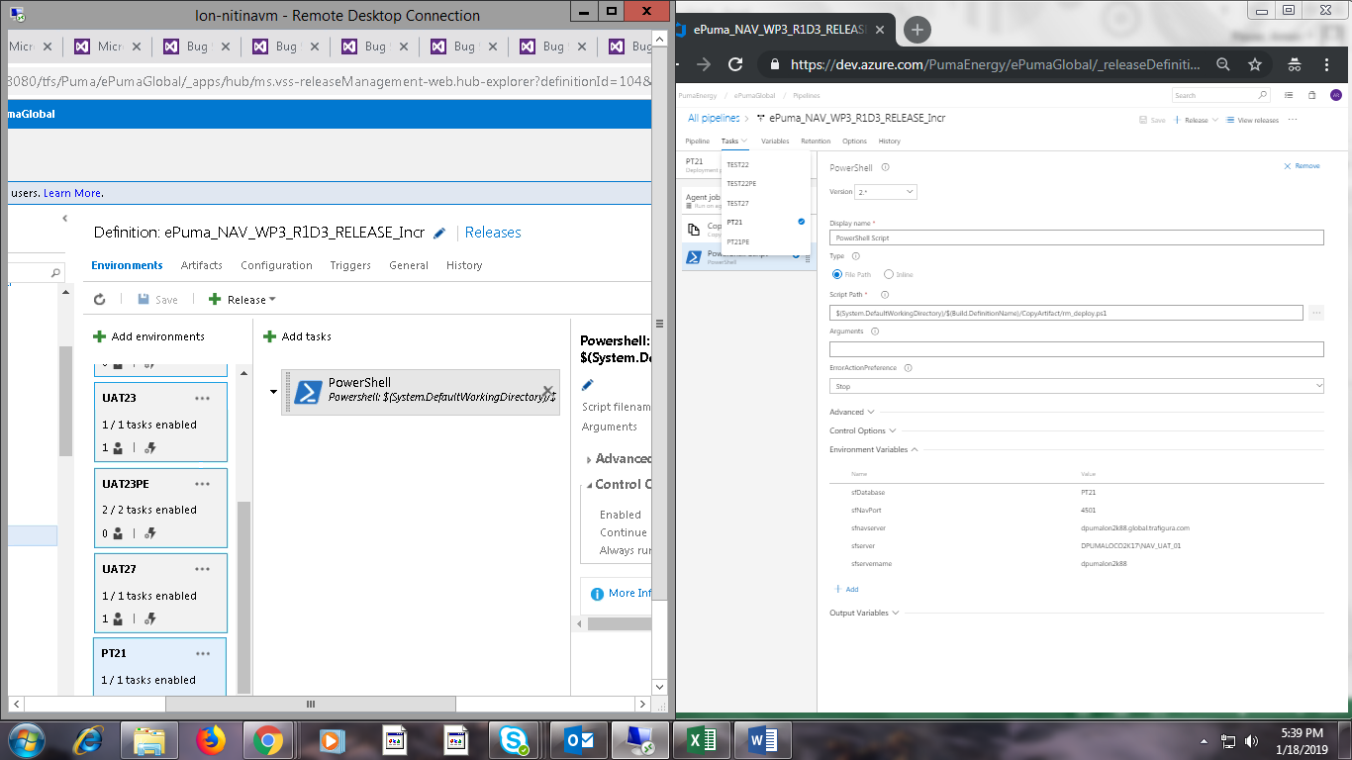

18. ePuma_NAV_WP3_SIT_TEST23_TEST25_Incr

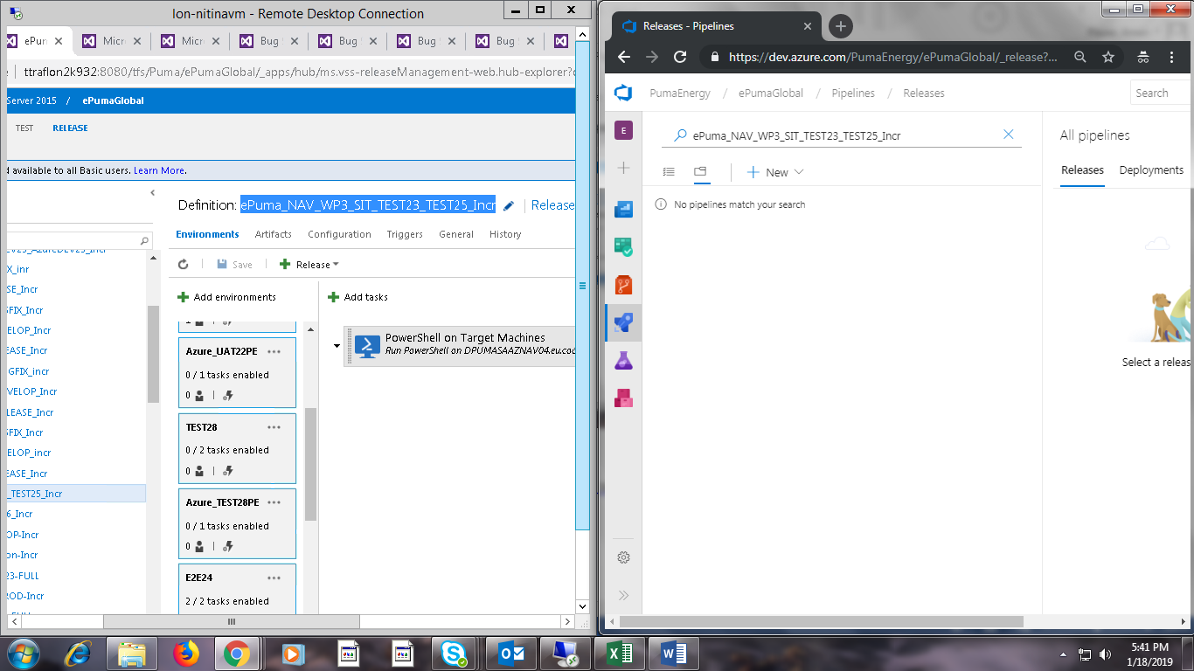

19. ePuma_NAV_WP3_UTA_DEV36_Incr

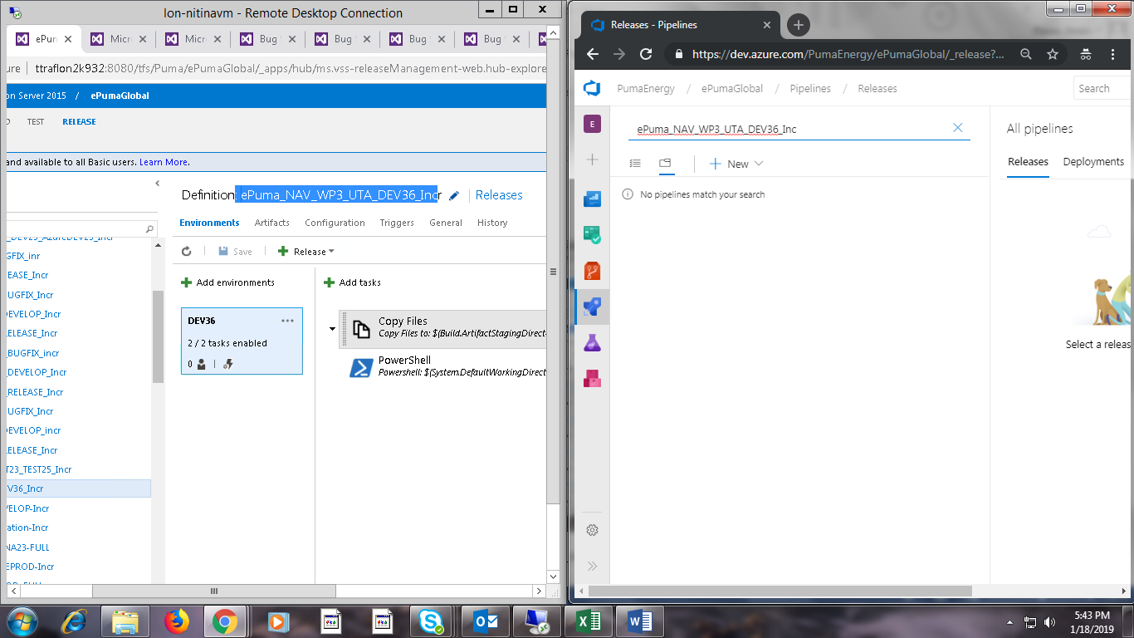

20. ePuma_NAV_WP3-OC-DEVELOP-Incr

